# API Store New User Request Instructions

## Process Flow

This is the process for requesting access to the NEXEN API Store. Same procedure applies for all regions (PROD, QA, TEST/DEV).



## Complete GAMO form 2012 for LDAP access to ‘NEXENAPIUsers’ group.

1. Go to [GAMO Website](http://intracf2.bnymellon.net/gamo/forms/index.cfm) and search for form # 2012

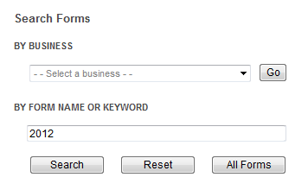

1. Select the ‘LDAP/Siteminder Set-up Access Request’ form

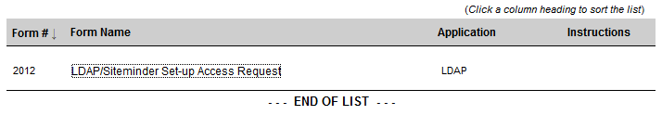

1. Select radio button to ‘Add/Remove Applications’ and enter your comit ID.

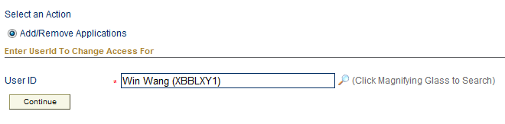

1. Select the checkbox for environments you need access. The bottom box, labeled ‘Selected’, will list the groups you are already assigned to. To assign to NEXEN API LDAP, select the ‘NEXENAPI Users’ value from the ‘Available’ list and click ‘Add’. The new group will be listed in the ‘Selected’ box prefixed with ‘Add –‘. Then click ‘Continue’.

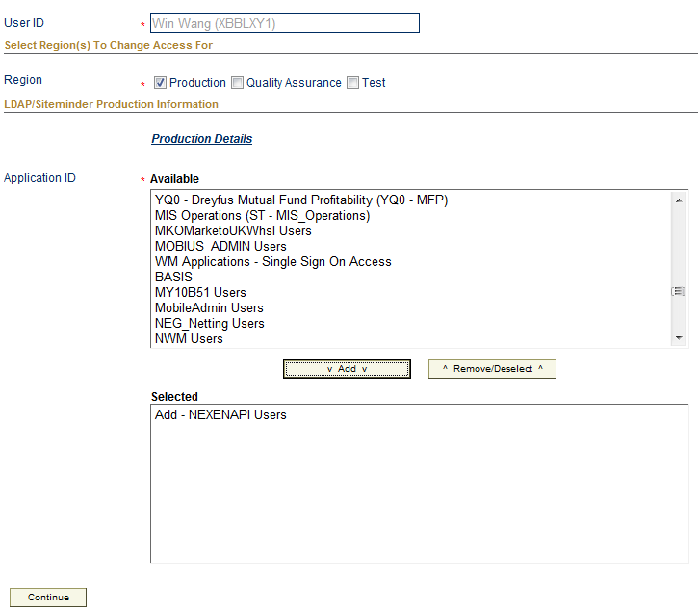

1. Once the page reloads, click ‘Continue’ at the bottom of the page. You can add a description to explain the request if needed.

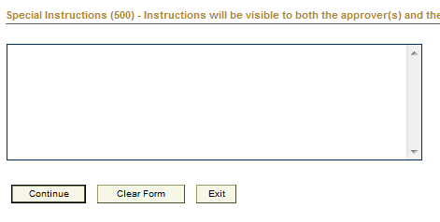

1. Select the correct approver. From the drop-down list labeled ‘SAA for requested User’. Then click ‘Continue’.

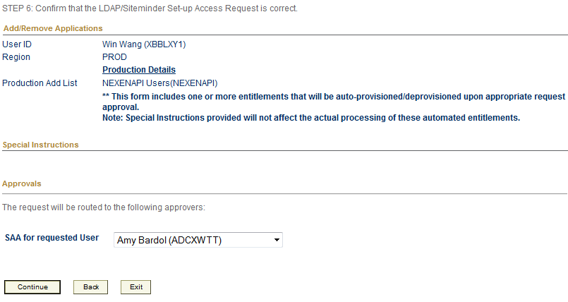

1. Review the confirmation page. The request number is at the top of the page.

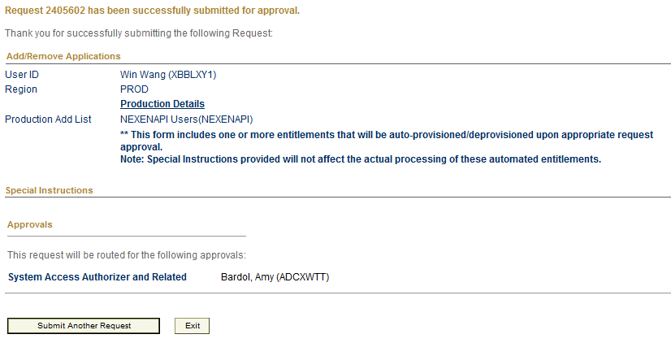

1. Follow up with the approver to ensure they complete the approval process.
2. Once they complete the approval process, you will be able to access the API Store and view/subscribe to APIs.